**TEST CASE DESIGN TECHNIQUES**

It is a technique which is used while writing test case in order to improve test coverage.

Types of Test case design techniques:

1. Error guessing
2. Equivalence class partitioning
3. Boundary value analysis (BVA)

1. ***Error Guessing:***

Here we guess all possible errors and we derive the scenarios.

We guess errors based on:

i.Requirement

ii.Experience

iii.Intuition

1. ***Equivalence class partition:***

* 1. **Pressman Rule:**

*Rule 1:* If the input is a range of values, then design test case for one valid and two invalid inputs.

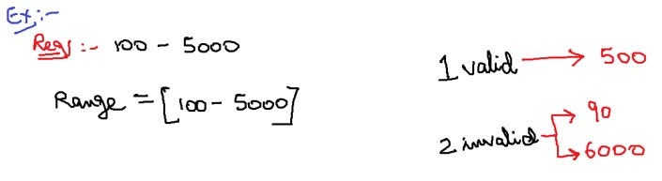

*Rule 2:* If the input is in a set of values, then design test case for one valid and two invalid inputs.

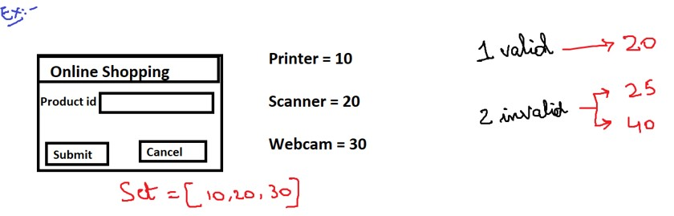

*Rule 3:* If the input is in Boolean, then design the test case for both true and false values.

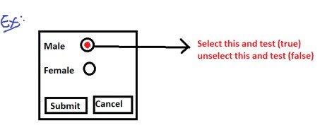 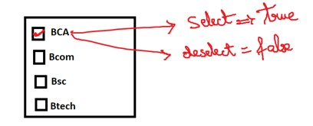

* 1. **Practice Method:**

If the input is in range of values then divide the range into equivalent parts and test for all the values, make sure that you are testing for at least two invalid values.

**Note:**

1. If there is a deviation between the range of values then we go got for Practice method.
2. If there is no deviation between the range of values then we go for Pressman rule.
3. By looking into requirements, we will get to know whether there is a deviation or not.

***3. Boundary Value Analysis:***

If the input is range of values b/w A to B then design test case for A, A+1, A-1 and B, B+1, B-1.

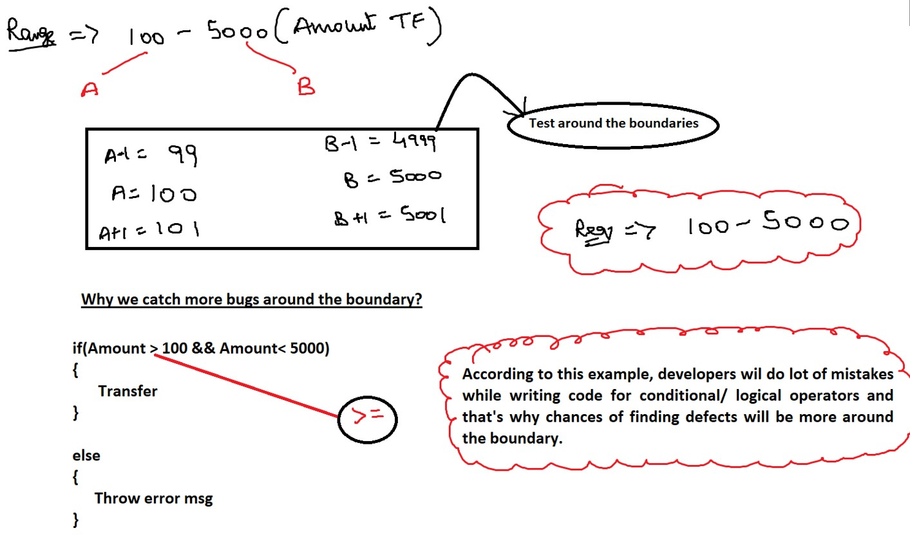

**Test case optimization:**

The process of removing the duplicates from the test cases (OR) Removal of repetition of test cases is called test case optimization. We can cover both 1 valid and 2 invalids in BVA itself, so we can skip equivalence partitioning (in only specific cases.